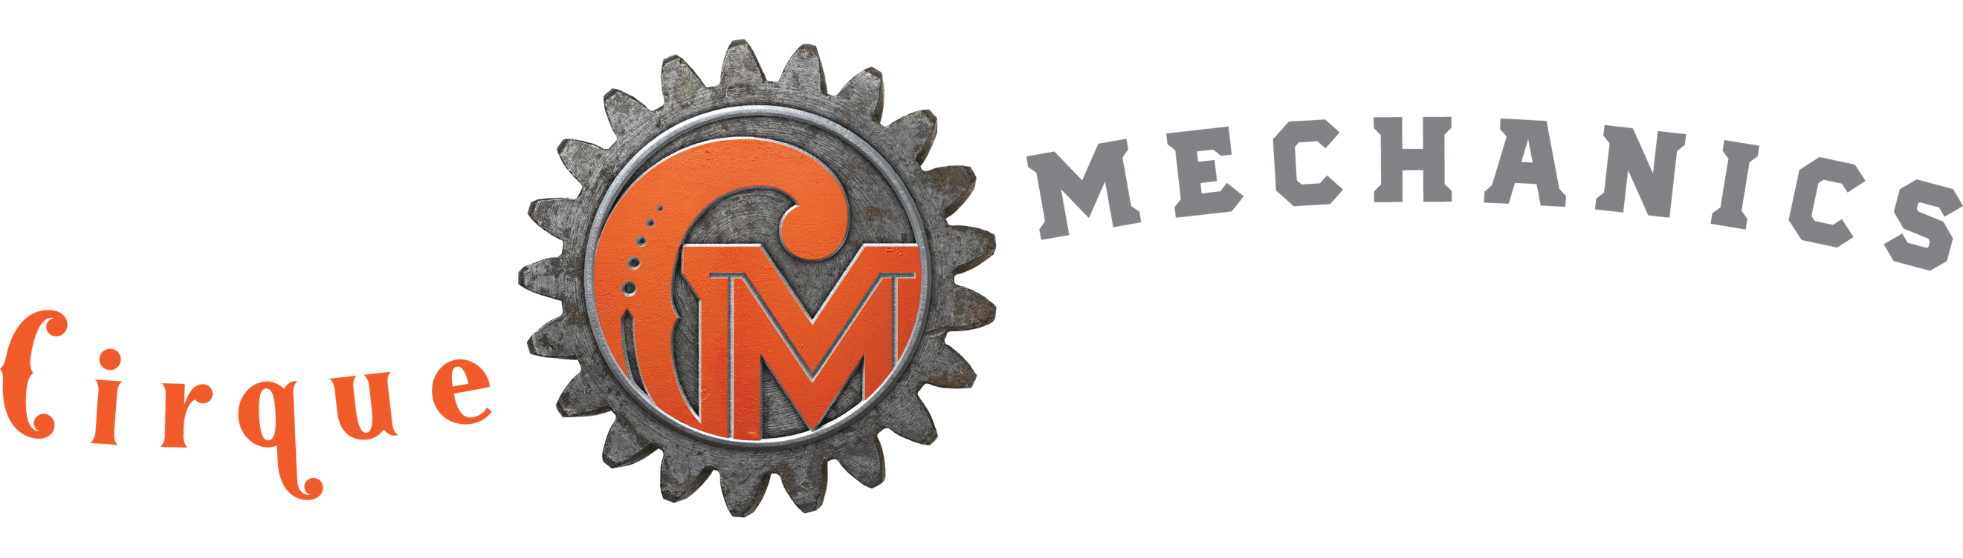 SPIN CYCLE
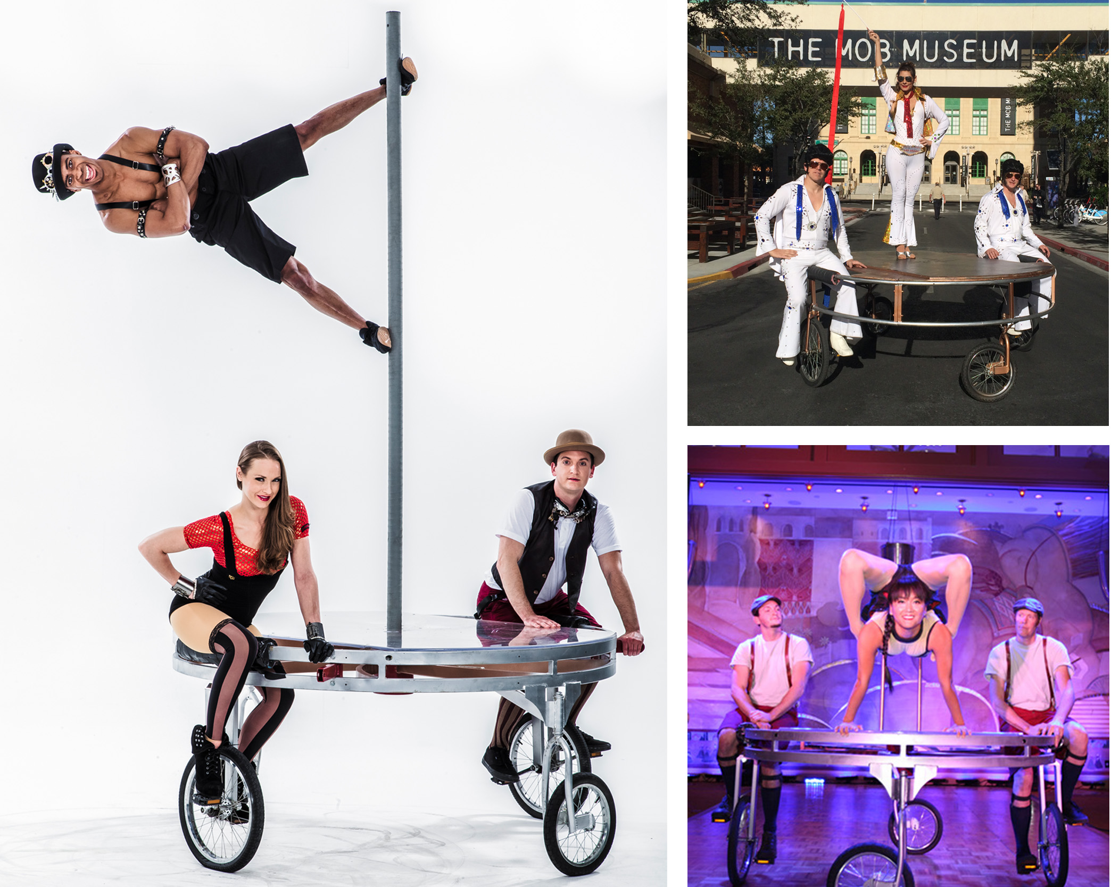

This 7' diameter platform is a roving stage. The Spin Cycle moves through event spaces with ease as artists pedal it slowly to create moving spectacles. The stage's 36" height puts talent head and shoulder above seated patrons. For this reason it is a great showcase for most any circus act or product. Furthermore, the device is also a wonderful way to deliver your CEO or guest speaker to the stage.

FAQs
What are the dimensions? It has a diameter of 7’ and is 3’ tall.
How much room is required for operation? A 9’ aisle is requested.
What surface is required for operation? The Spin Cycle can be driven on most level surfaces: Carpet, dance floor, asphalt, concrete, pavers are acceptable. Movement on close cut grass is also possible.

How fast does the Spin Cycle move?
While it can travel at the pace of a quick walk, it is typically driven very slowly.

How do you manage crowded spaces? We are accustomed to performing in crowded spaces. Movement of the Spin Cycle is accomplished using an artist as escort.
What lighting and sound support is required?
We bring wireless LEDs for accent lighting but theatrical lighting is needed to feature the artists/acrobatic acts. Spin Cycle audio requires house PA. If choreographed acts are performed, the Cirque Mechanics artistic manager operates sound from company laptop plugged into sound console.

What acts can be performed on the Spin Cycle? The Spin Cycle can present a wide array of circus acts: juggling, contortion, pole, handstand, duo balancing, rola bola and hula hoop are commonly featured.

Can the Spin Cycle be used to serve/support hospitality?
Yes, the Spin Cycle has a 6’ diameter surface that can be used to deliver food, display ice sculptures, specific décor, company products… the possibilities are endless.
Can specific acts be requested? Yes.
Can the Spin Cycle be used to deliver CEO’s/ guest speakers? Yes, this is a common request. We have delivered guest speakers, and CEOs. It is also possible for client representatives to be trained to drive the device.

How is the Spin Cycle transported? For events within 500 miles of Las Vegas or Orlando, the device is brought in by truck. Distances greater than 500 miles require the Spin Cycle

to be shipped via our freight service in a 72” x 72” x 24” wheeled crate. The client must support receipt and local transportation of crate.

How long does it take to build and strike? If trucked in, it can be tipped back rolled through a set of double doors and ready to go in minutes. To strike, tip it back and roll out the door. If shipped in its crate, it can be assembled on site. The Spin Cycle can be built in under two hours.

Do we require any local crew? No, our pricing includes all the labor.

Does the Chariot provide any branding opportunities? Yes, the 12” tall frame surrounding the perimeter can be used for placement of client artwork. See our Branding document located on the Proposal Support page on our website.

