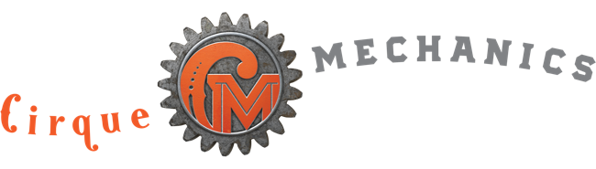 SS Gantry 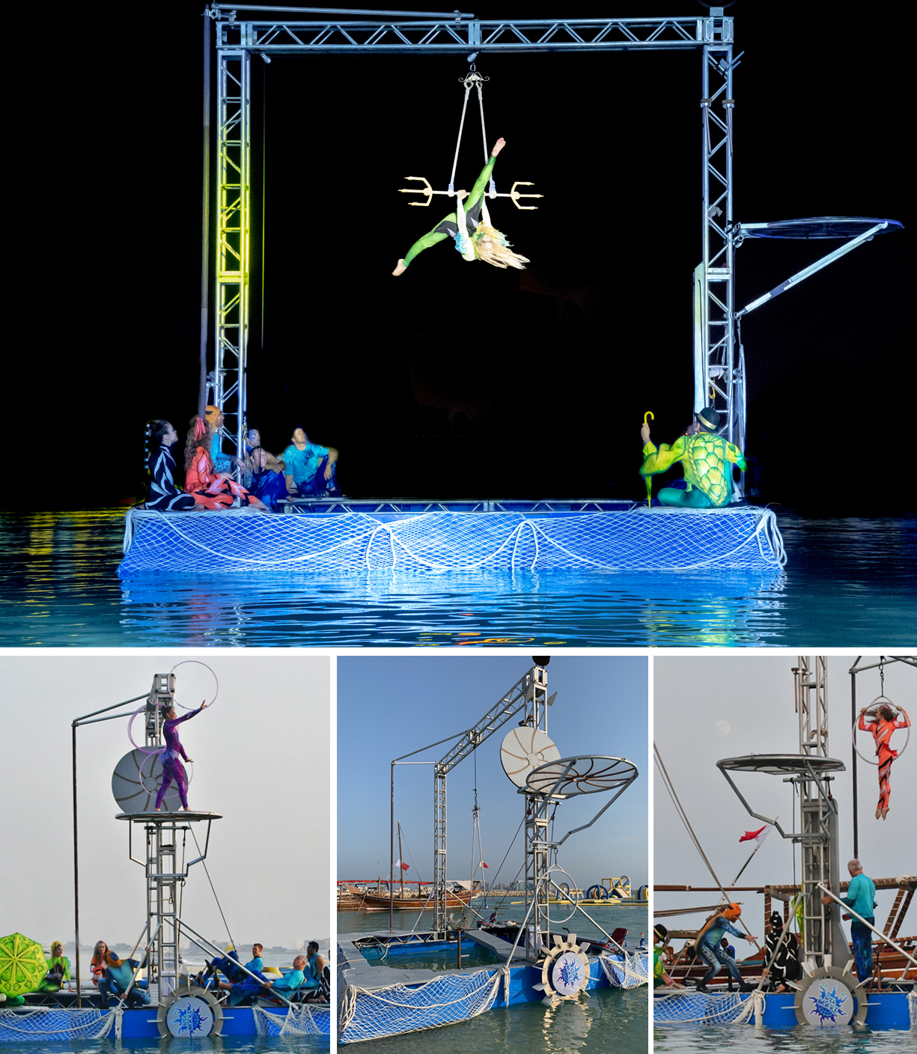

This floating aerial platform provides all the elements of our land based Gantry Bike. While modular and adjustable in size we normally build this water device 20' x 20'. Although its most unique feature is the rigging to support aerial acts, it also

provides an elevated platform for ground-based acts. In the past to create this kind of effect, planners would need to build stages IN the pool. Aside from the steep cost of built in stage solutions many venues are protective of their pool surfaces. As the SS Gantry uses plastic floats and paddles there is nothing to damage these pool surfaces. For these reasons this device is the perfect solution for water side events where real estate for entertainment is limited.

FAQs
- What are the dimensions? 20’ wide x 20’ long x 18’ tall.
- How heavy is it? The SS Gantry weighs approximately 1800 pounds.
- How much room is required for operation? A minimum pool width of 24’ wide is required. Optimal pool size to support full rotation is 28’ x 28’. The SS Gantry requires the water to have a depth of at least 18”.
- How fast does the SS Gantry move? The two large paddle wheels are quite efficient but the biggest factor with speed of the SS Gantry is wind. If wind is minimal it can move at the equivalent of a slow walk.
- Do we require any local crew? No, our pricing includes all labor needed to build and operate the Gantry. Client must manage local labor restrictions/guidelines imposed by organized labor contracts.
- How long does it take to build? … and strike? We request a six-hour window for the build, but this requires a clear understanding of pool access for load in of gear. Strike can be accomplished in two hours.
- What kind of acts can the SS Gantry support? This device was designed to provide the same support of aerial and ground acts as its land based version. The central rigging point can support aerial acts such as aerial hoop, trapeze, aerial rope, straps and tissue. The elevated platform can support acts such as juggling, hula hoop and contortion.

- What lighting and sound support is required for the Gantry? We provide optional wireless LED’s to accentuate the SS Gantry, but theatrical lighting is required by the venue to feature the artists/acrobatic acts. Additional fixtures should be considered to support Gantry positions . SS Gantry audio requires house PA. Cirque Mechanics stage manager runs sound from company laptop plugged into sound console.
- How is the SS Gantry transported? For events in North America the SS Gantry is brought in by truck. International events require the shipping in a 20’ ocean container.
- Does the SS Gantry provide any branding opportunities? Yes, the truss uprights and central span can be covered with branded panels. See our Branding document on the Proposal Support page of our website.

