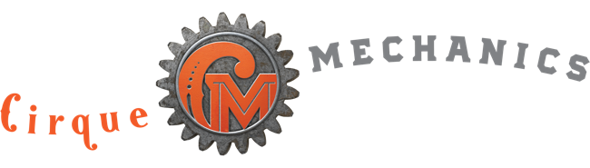 Paddleship 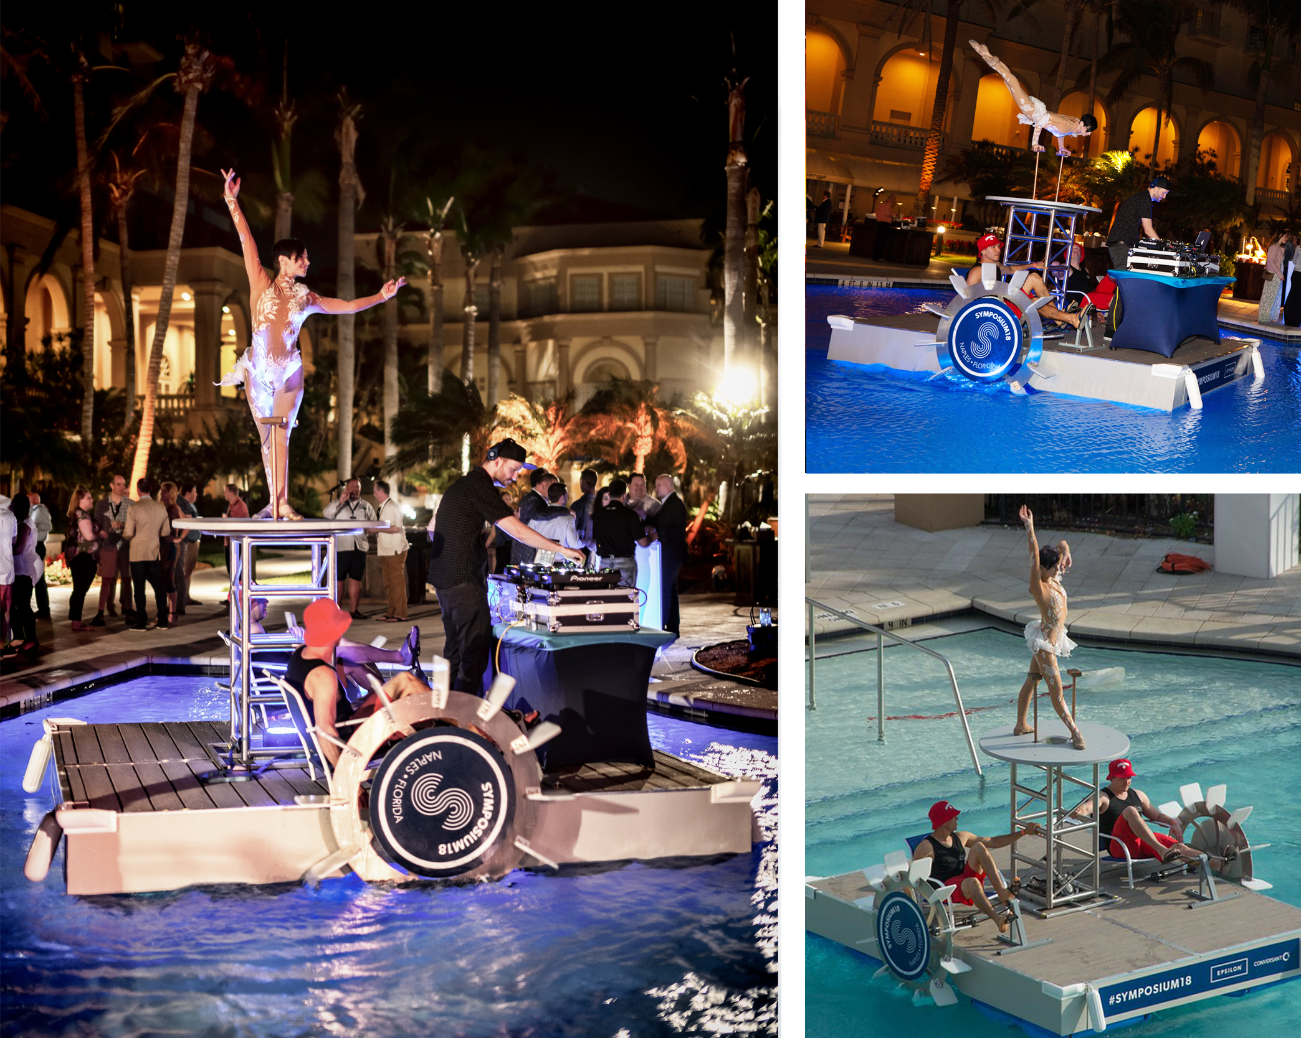

A pedal driven floating platform, inspired by early paddle boats, the Paddle Ship, can make any pool, lake or pond the stage at your next event. This water device can support a wide variety of options from DJs to fire breathers and all of the same ambient talent and circus acts as our land based roving apparatus. In the world post Covid, space for entertainment at poolside events will get even more scarce, making the Paddleship a perfect solution for these galas.

FAQs
- What are the dimensions? 10’ wide x 12’ long.
- How heavy is it? The Paddleship weighs approximately 600 pounds.
- How big a pool is required? A minimum width of 14’, but a size of 20’ x 20’ allows for full rotation. Alternate configurations are available for smaller pools. The Paddleship requires the water to have a depth of at least 18”.
- Will the Paddleship damage the pool? As the Paddleship uses plastic floats and paddles there is nothing to damage these delicate pool surfaces. The build of the Paddleship takes place adjacent to the pool on a protective ground covering.
- Do we require any local crew? No, our pricing includes all labor needed to build and operate the Paddleship. Client must manage local labor restrictions and guidelines imposed by organized labor contracts.
- How long does it take to build and strike? We request a four-hour window for the build, but this requires a clear understanding of pool access for load in of gear. Strike can be accomplished in 1 1/2 hours.
- What kind of acts can the Paddleship support? This device was designed to provide the same support of ground acts as our Spin Cycle device. It can support ground acts such as juggling, hula hoop and contortion, and the water element makes is a perfect device for fire performances.
- What lighting and sound support is required for the Paddleship? We provide optional wireless LEDs to accentuate the Paddleship, but theatrical lighting is recommended to feature the artists/acrobatic acts. Paddleship audio requires house PA. Cirque Mechanics stage manager runs sound from company laptop plugged into sound console.
- How is the Paddleship transported? For events in North America the Paddleship is brought in by truck. International events require the shipping in a 20’ ocean container.
- Does the Paddleship provide any branding opportunities? Yes, the Paddlewheels provide good dynamic locations and the deck surround and pedestal upright can be covered with branded panels. See pics on the cover page and visit our Branding document on the Proposal Support page of our website.

