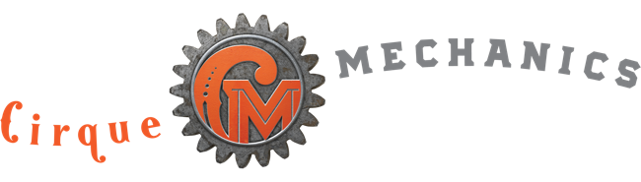 GANTRY BIKE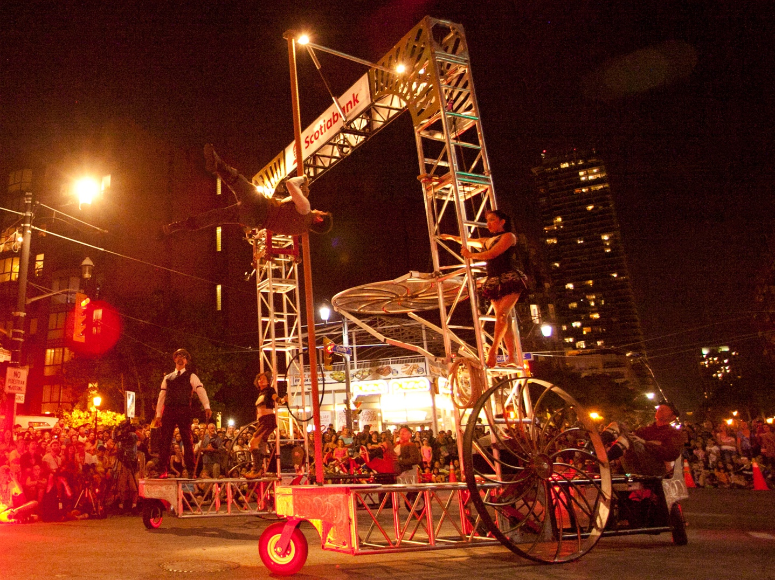
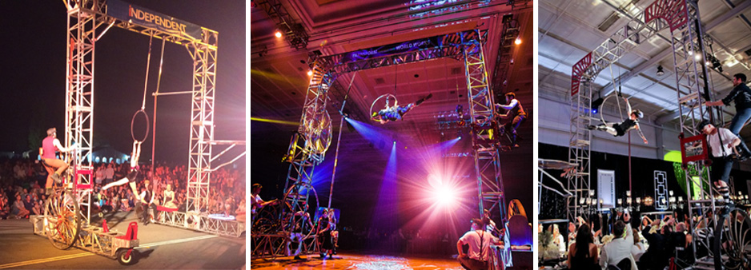
The Gantry Bike is a 20’ tall pedal-driven aerial apparatus, capable of roaming down festival streets or across hotel ballrooms. Imagine this: An aerialist swings and spins suspended high above the audience, a contortionist twists atop a Plexiglas table 10’ off the ground, an acrobat climbs and balances on a Chinese pole, and a juggler tosses and manipulates a series of props on the front pontoon platform.

Its impressive height allows for great sponsor and corporate branding opportunities. While designed to close the gap between stage production and roaming talent, the Gantry Show can also deliver a dynamic theater worthy production on any stage.
FAQs

1.What are the standard dimensions? 20’ tall x 18 ½’ wide x 15’ long
2. Can the size be modified? Gantry height is usually adjusted to comply with venue specifications. It is crucial to consider the lighting truss/chandeliers/décor and other logistical elements to determine the span and size of the Gantry, which can be modified to fit most any space. So far, we’ve provided the following spectrum of configurations:
- Height – tallest: 24’, shortest: 14’
- Width – widest: 28’, narrowest: 14’
3. How heavy is the Gantry? Can we use it on a temporary stage? The Gantry weighs approximately 2200 pounds, about as much as a small automobile (such as a Mini Cooper). It can be used on most temporary staging. It cannot be used on standard folding hotel risers.
4. How much room does it need to rotate? The Gantry requires a clear circle with a 26’ diameter to rotate.
5. How wide do the pathway aisles need to be to drive over tables? We generally request a width of 6’ to navigate each pontoon – meaning the standard Gantry with a 13’ spread between pontoon wheel units requires two requires two 6’ aisles with their centers 15’ apart. This leaves a space of just over 9’ between the aisles. We are happy to provide room diagram and aisle placement options upon request.
6. What can the Gantry drive over? Most anything within reason: dining tables, buffets, bars, fountains, trade show booths, seating areas, etc.
7. What ground surface is required for Gantry operation? It’s versatile and adaptable to most level surfaces, including carpet, dance floor, asphalt, concrete,

pavers, etc. Special preparations required to operate on close cut grass and other soft surfaces.
8.How fast does the Gantry move? While the top speed is about 5mph, it generally moves more slowly for effect, about the speed of a slow walk.
9. How do you manage crowded spaces? Moving and operating the Gantry is performed by our artists, who also act as escorts along each pontoon. We are accustomed to crowded venues and ensure the safety element as an integral part of the presentation.
11.What acts can be performed on the Gantry? We commonly offer a combination of aerial and ground acts. A typical show might feature juggling, contortion, pole, aerial hoop, aerial rope, cyr wheel, trick cycling.
- Can specific acts be requested? Yes
11.What lighting and sound support is required for the Gantry? We provide wireless LED’s to accentuate the Gantry Bike, but theatrical lighting is required by the venue to feature the artists/acrobatic acts. Additional fixtures should be considered to support Gantry positions throughout the room. Gantry audio requires house PA. Cirque Mechanics stage manager runs sound from company laptop plugged into sound console.

10. Can Aerial Bartending be conducted from the Gantry? Absolutely! Aerial bartending is typically performed from outriggers (sections of truss extending from each end) so that libations can be poured from either side of the Gantry.
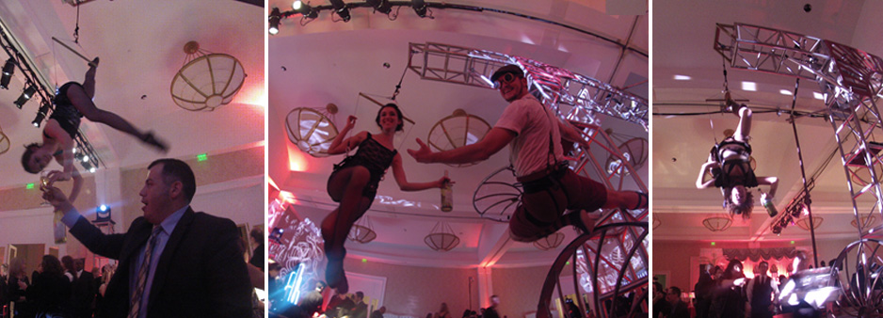

12.How long does it take to build? … and strike? We request a 4-hour window for build. IF the room turnover is shorter, the setup can be quicker by adding crew. The strike is done immediately after the event and takes less than 2 hours.
13.Do we require any local crew? No, our pricing includes all labor needed to build and operate the Gantry. Client must manage local labor restrictions/guidelines imposed by organized labor contracts.
16.Can the Gantry be used to introduce CEO’s/ guest speakers? Yes, this is a common request. We have introduced guest speakers and CEOs by delivering them aboard the Gantry from the back of the room to the stage. This is very common highlight for general sessions. The Gantry features a secure platform 10’ above ground for the dramatic entry. Want to go still higher? We can use the uppermost aerial point to suspend the VIP speaker over guests as the Gantry makes its way through the space.
17.How is the Gantry transported? In the U.S. the apparatus travels in a 16’ truck. It arrives onsite in 4 large truss stacks that are rolled into the venue. The Gantry requires one 20’ container for international shipping.
18.Is the Gantry “trampoline act” available for corporate events? Developed for our touring theatrical show “Pedal Punk” , (click to view)
the trampoline act is available on special order. The act necessitates the standard Gantry configuration of 18.5’ wide. The trampoline structure can be removed for aerial acts, but it requires a storage pace of 10 x 7’, either onstage or adjacent to the event space.

