 CHARIOT 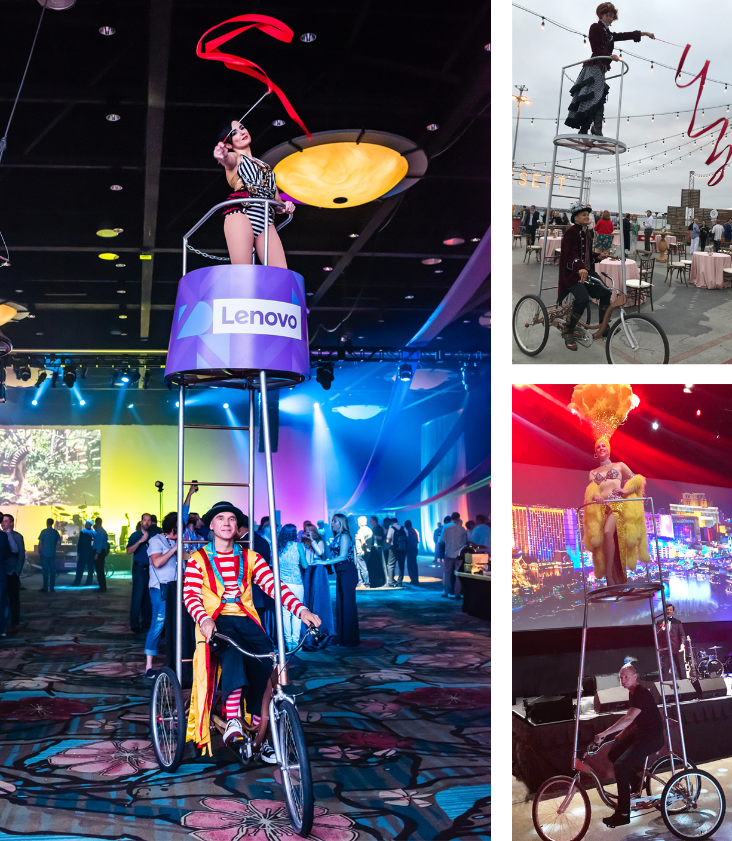

The Chariot is a 10’ tall pedal driven stage. It provides a small platform, is nimble and able to navigate small spaces. Its benefit is the increased visibility it provides for roving talent. It is also a fantastic way to deliver your guest speaker or CEO to the stage. The upper platform provides additional branding opportunities. Bring your roving talent to a whole new level with the Chariot.
FAQs
- What are the dimensions? The Chariot Bike is 6’ long x 39” wide x 13’6” tall.
- How much room is required for operation? A 4’ aisle is recommended.
- What surface is required for operation? The Chariot Bike can be driven on most surfaces: Carpet, dance floor, asphalt, concrete, pavers are acceptable. Movement on close cut grass is also possible.
- How fast does the Chariot Bike move? It is driven at the pace of a slow walk.
- How do you manage crowded spaces? We are accustomed to performing in very crowded spaces.
- What kind of acts can the Chariot support? Ambient acts like contortion, juggling and hula hoop, but we have also transported showgirls, CEOs and politicians.
- How is the Chariot transported? For events within 500 miles of Las Vegas or Orlando, the Chariot is brought in by truck. Distances greater than 500 miles require the device to be shipped via our freight service in a 72” x 72” x 24” wheeled crate. The client must support receipt and local transportation of crate.
- How long does it take to build and strike? If trucked in, it can be tipped back rolled through a set of double doors and ready to go in minutes. To strike, tip it back and roll out the door. If shipped in its crate, it can be assembled on site. The Chariot can be built in under two hours.
- Do we require any local crew? No
- Does the Chariot provide any branding opportunities? Yes, the 36” railing and platform surround can be used for placement of client artwork. (see page one)

