 CAROUSEL
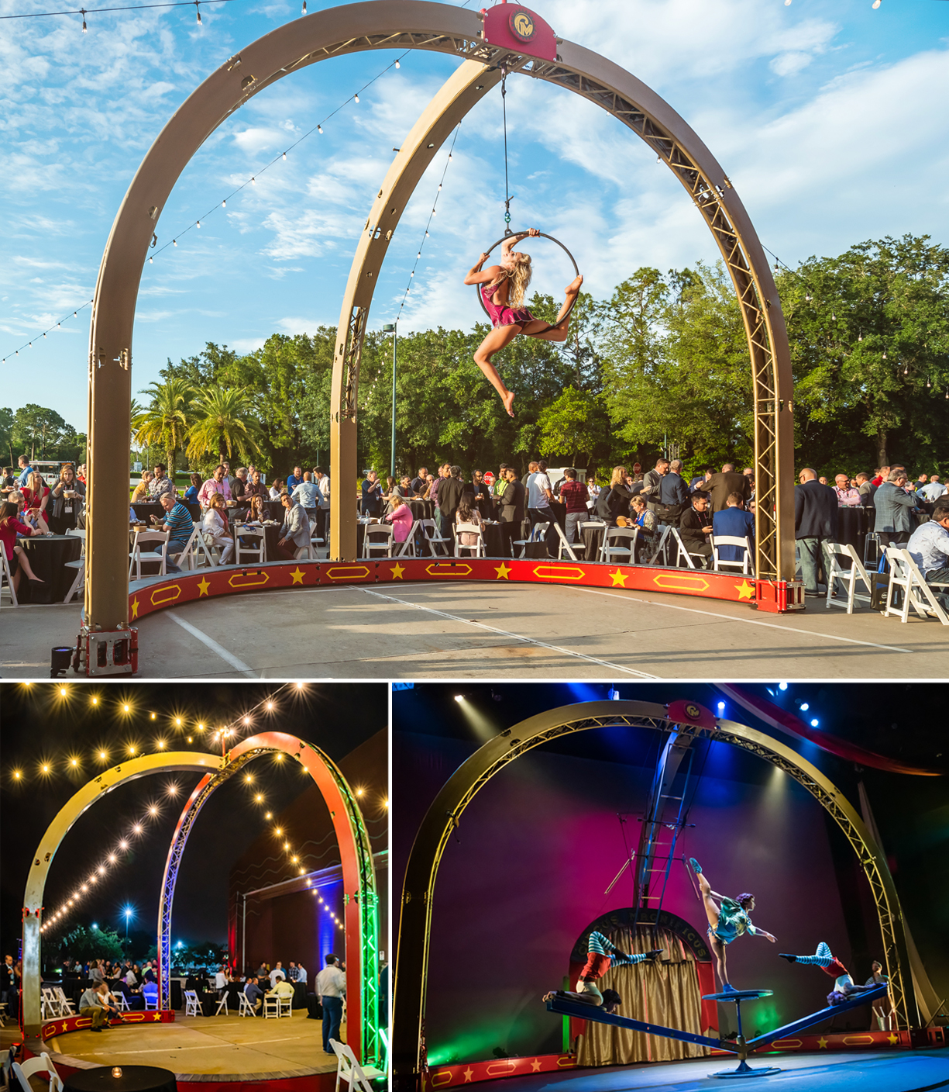

Designed for our stage show “42ft – A Menagerie of Mechanical Marvels”. The Carousel is a ground supported, free standing, revolving circus ring and aerial frame. It is a great solution for venues that don’t support overhead rigging is also a great focal element in any room or outdoor space.

FAQs

What are the standard dimensions? 20’ tall x 24’ wide x 15’ deep
Can the size be modified? no
How heavy is the Carousel? Can we use it on a temporary stage? The Carousel weighs approximately 1200 pounds, about as much as a two golf carts. It can be used on most temporary staging. It cannot be used on standard folding hotel risers.
How much room does it need to rotate? The Carousel requires a clear circle with a 26’ diameter to rotate.
What ground surface is required for Carousel operation? It’s versatile and adaptable to most level surfaces, including carpet, dance floor, asphalt, concrete,
pavers, etc. Special preparations required to operate on close cut grass and other soft surfaces.
How do you manage crowded spaces? Rotating the Carousel is performed by our artists, who also act as escorts along each end. We are accustomed to crowded venues and ensure the safety element as an integral part of the presentation.
What acts can be performed on the Carousel? We commonly offer a combination of aerial and ground acts. A typical show might feature juggling, contortion, aerial hoop, aerial rope, slack wire, cyr wheel, trick cycling.

Can specific acts be requested? Yes
What lighting and sound support is required for the Carousel? We provide wireless LED’s to accentuate the Carousel Bike, but theatrical lighting is required by the venue to feature the artists/acrobatic acts. Additional fixtures should be considered to support Carousel positions throughout the room. Carousel audio requires house PA. Cirque Mechanics stage manager runs sound from company laptop plugged into sound console.

Can Aerial Bartending be conducted from the Carousel? Absolutely! Aerial bartending is typically performed from the central rigging point.

How long does it take to build? … and strike? We request a 4-hour window for build. IF the room turnover is shorter, the setup can be quicker by adding crew. The strike is done immediately after the event and takes less than 2 hours.
Do we require any local crew? No, our pricing includes all labor needed to build and operate the Carousel. Client must manage local labor restrictions/guidelines imposed by organized labor contracts.
How is the Carousel transported? In the U.S. the apparatus travels in a 16’ truck. It arrives onsite in 4 large truss stacks that are rolled into the venue. The Carousel requires one 20’ container for international shipping.

