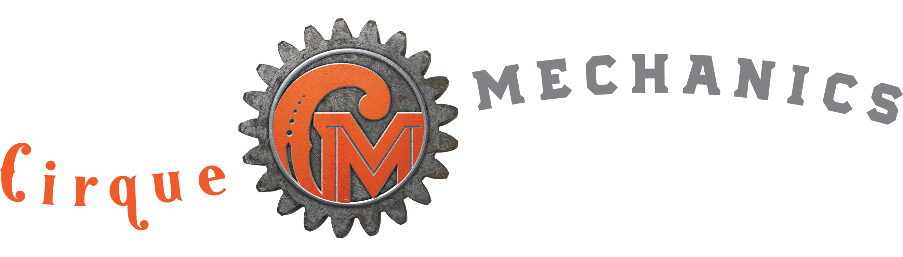 BUFFET TRAIN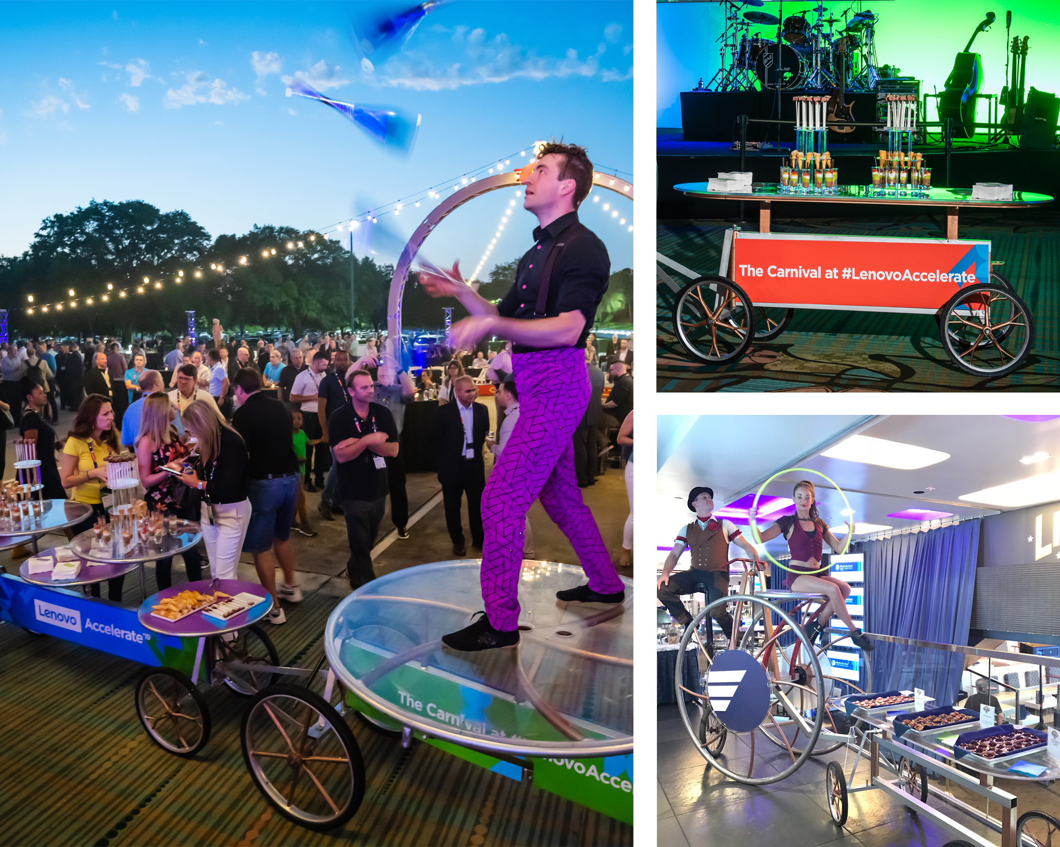

The Buffet Train is a rolling food service device comprised of one trike, two rolling tables and one stage wagon. While it is over 40' long it can be driven through event spaces quite safely. The train can also be parked and used as a focal design element. Although the wagons were initially designed for food service, they have also delivered awards and even been used to display silent auction items. Generally, this device is packaged with two to four acrobats but it is possible to hire without talent. The Mini Buffet is comprised of one trike and one shorter food service wagon. This version is advantageous when the room size or budget will not support the full version.

FAQs
- What are the dimensions? The complete train is 40’ long x 48” wide x 6’ tall.
- How much room is required for operation? A 6’ aisle is recommended.
- What surface is required for operation? The Buffet Train can be driven on most level surfaces: Carpet, dance floor, asphalt, concrete, pavers are acceptable. Movement on grass close cut grass is also possible.
- How fast does the Buffet Train move? While it can travel at the pace of a quick walk it is typically driven very slowly.
- How do you manage crowded spaces? We are accustomed to performing in very crowded spaces. Our artists serve as escorts to keep guest and food safe
- What exactly are the surfaces available for food service?

Each Buffet Train service wagon contains five 28” diameter round platforms (10 in total). The Mini Buffet provides one surface that is 24” wide x 6’ long.
- Do we require any local crew? Local catering staff is required for loading and resupply of food items.
- What other things can the Buffet Train be used for? The wagons can be used to deliver giveaways, coffee, box lunches, or display new products.
- How is the Buffet Train transported? For events within 500 miles of Las Vegas or Orlando, the unit is brought in by truck. Distances greater than 500 miles require it to be shipped via our freight service in two 72” x 72” x 24” wheeled crates. The client must support receipt and local transportation of crates.
- How long does it take to build and strike? If trucked in, it can be unloaded out of the truck, rolled through a set of double doors and ready to go in minutes. To strike, roll the units out the door. If shipped in its crates, it can be assembled on site. The Buffet Train can be built in under two hours.
- Does the Buffet Train provide any branding opportunities? Yes, the optional trike wheel covers (36” diameter) can each be branded. Brandable wheel covers 20” diameter can also be provided for the food service and stage wagons. The food service and stage wagon frames also provide 12” tall x 6’ surfaces on each side. See our branding document on the Proposal Support page on our website for more detailed branding opportunities.

