 WINE BIKE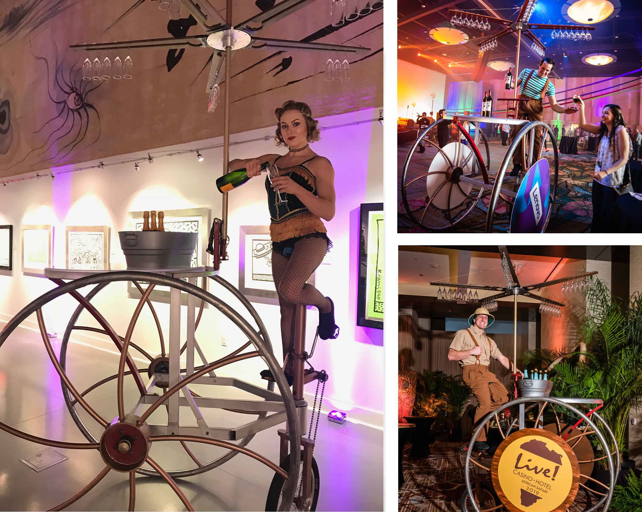

The Wine Bike makes serving your favorite burgundy or bubbly utterly memorable. The pedal-driven hospitality device is equipped with a five-blade propeller that holds up to forty-five stem glasses. The propeller is 9’ high and rotates while the Wine Bike (also called the Trike) is ridden by a single artist/server who is included in a standard 2-hour contract.

FAQs
- What are the dimensions? 6’ long x 39” wide x 11’ tall.
- How much room is required for operation? A 4’ aisle is recommended.
- What surface is required for operation? The Wine Bike can be driven on most level surfaces: Carpet, dance floor, asphalt, concrete, pavers are acceptable. Movement on close cut grass is also possible.
- How fast does the Wine Bike move? It is driven at the pace of a slow walk.
- How do you manage crowded spaces? We are accustomed to performing in very crowded spaces. The turning mechanism allows for the Trike to rotate on a dime.
- Does the client need to provide beverages, ice, or glasses?

Yes, the venue/client must provide all three. Stemmed wine glasses must have a base of at least 2” in diameter with a stem no thicker than ½”. We also provide an onboard ice bucket large enough to chill 6 wine bottles.
- Can the Wine Bike be used to serve things other than beverages? Yes, the propeller blades can be used to serve a myriad of goodies, such as cotton candy, bags of popcorn or buckets of nuts, etc...
- How is the Wine transported? For events within 500 miles of Las Vegas or Orlando, the device is brought in by truck. Distances greater than 500 miles require the device to be shipped via our freight service in a 72” x 72” x 24” wheeled crate. The client must support receipt and local transportation of crate.
- How long does it take to build and strike? If trucked in, it can be tipped back, rolled through a set of double doors and ready to go in minutes. To strike, tip it back and roll out the door. If shipped in its crate, it can be built in two hours.
- Do we require any local crew? No, the Wine Bike is completely self-contained.
- Does the Wine Bike provide any branding opportunities? Yes, the optional 36” diameter wheel covers can be used for placement of client logos and artwork. See our Branding document located on the Proposal Support page on our website.).

